**Wire-Frame Design**

**STORE SALES PREDICTION**

|  |  |
| --- | --- |
| Written By | Mohammad Danish, Nandani Gupta  Deeksha Sharma ,Nitin Kushwaha |
| Document Version | 1.0 |
| Last Revised Date | 28-Nov-2021 |

**Document Change Control Record**

|  |  |  |  |
| --- | --- | --- | --- |
| **Version** | **Date** | **Author** | **Comments** |
|  |  |  |  |
|  |  |  |  |
|  |  |  |  |
|  |  |  |  |
|  |  |  |  |
|  |  |  |  |
|  |  |  |  |
|  |  |  |  |
|  |  |  |  |
|  |  |  |  |
|  |  |  |  |
|  |  |  |  |
|  |  |  |  |
|  |  |  |  |
|  |  |  |  |
|  |  |  |  |

**Reviews**

|  |  |  |  |
| --- | --- | --- | --- |
| **Version** | **Date** | **Reviewer** | **Comments** |
|  |  |  |  |

**Approval Status:**

|  |  |  |  |  |
| --- | --- | --- | --- | --- |
| **Version** | **Review date** | **Reviewed By** | **Approved By** | **Comments** |
|  |  |  |  |  |

# Homepage

On the homepage the user will be able to see the heading of the project name and there will be icon of GitHub and LinkedIn to connect to the developer, at the right hand side there will be image related to the product and after that there will be inputs which user needs to give.

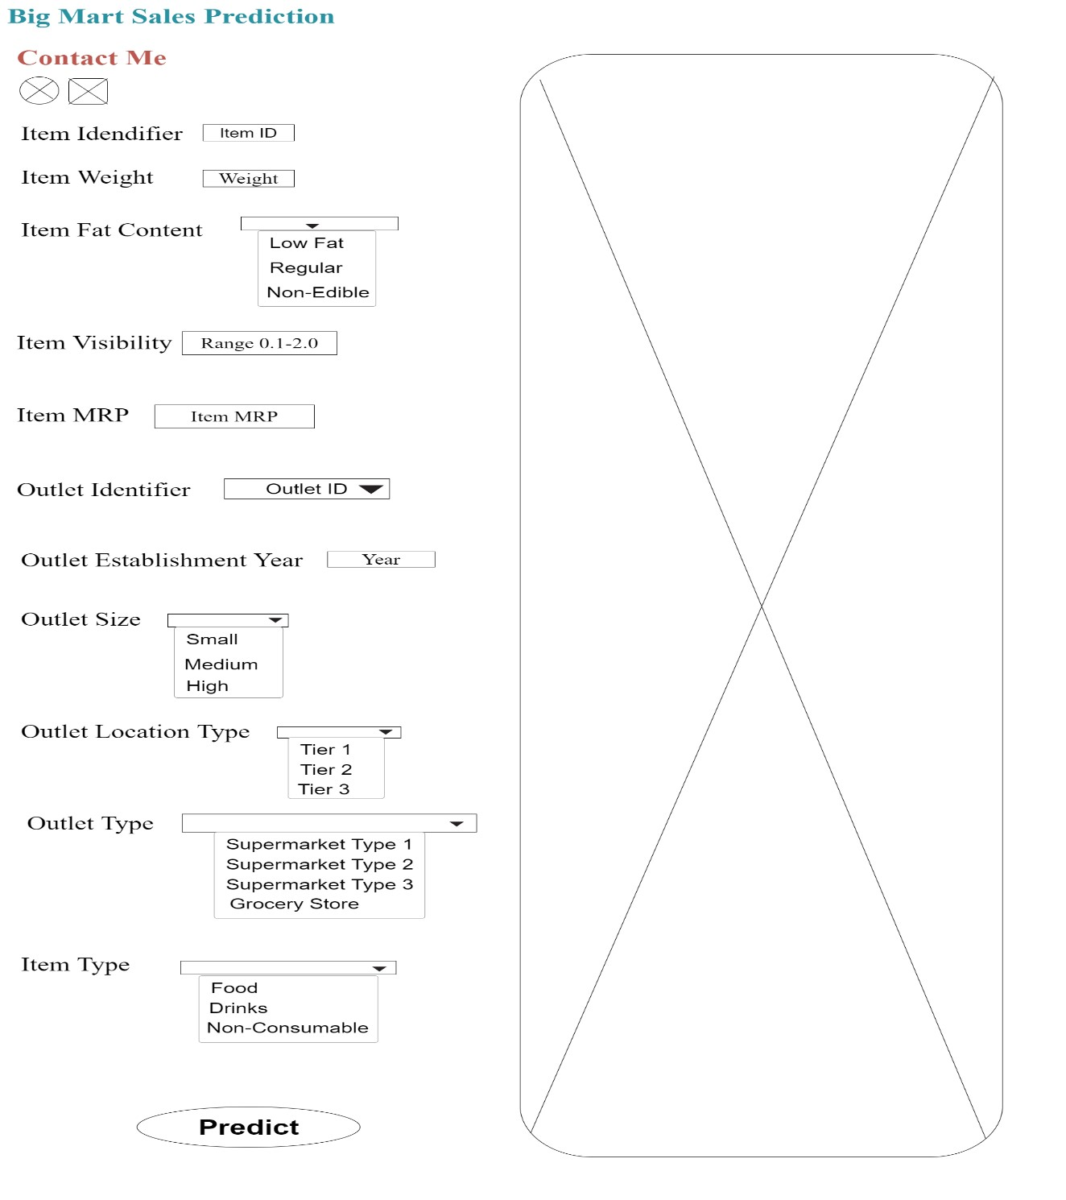

# Prediction Page

After the user will give inputs there will be predict button, on clicking predict button the next page will open which will be the result page where the prediction will be shown for the given inputs. Below is the image how the result page will look like:

